Name: M.Sai Chaitanya Roll No:2520090023
Practical week-2
Step 1 — Create Database
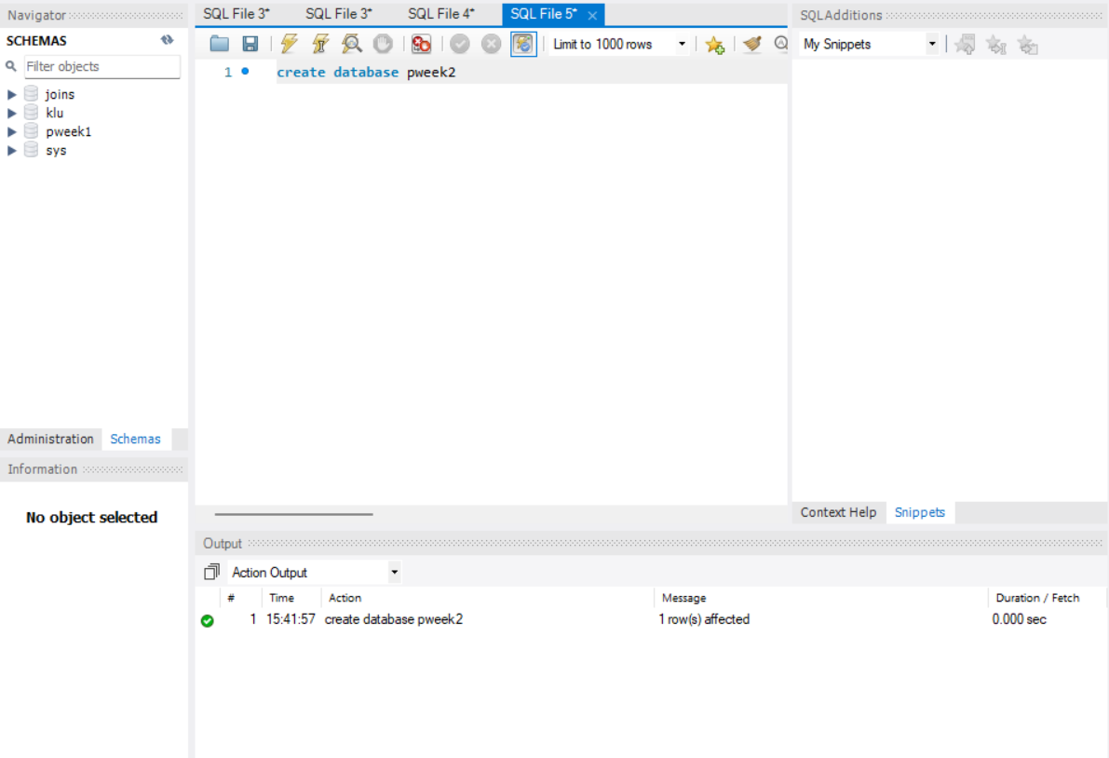
Step 2 — Create Books Table (DDL + Constraints)
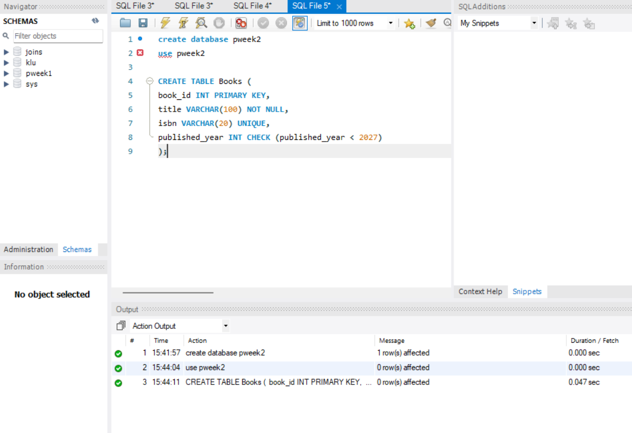
Step 3 & 4 — Insert Books and Display
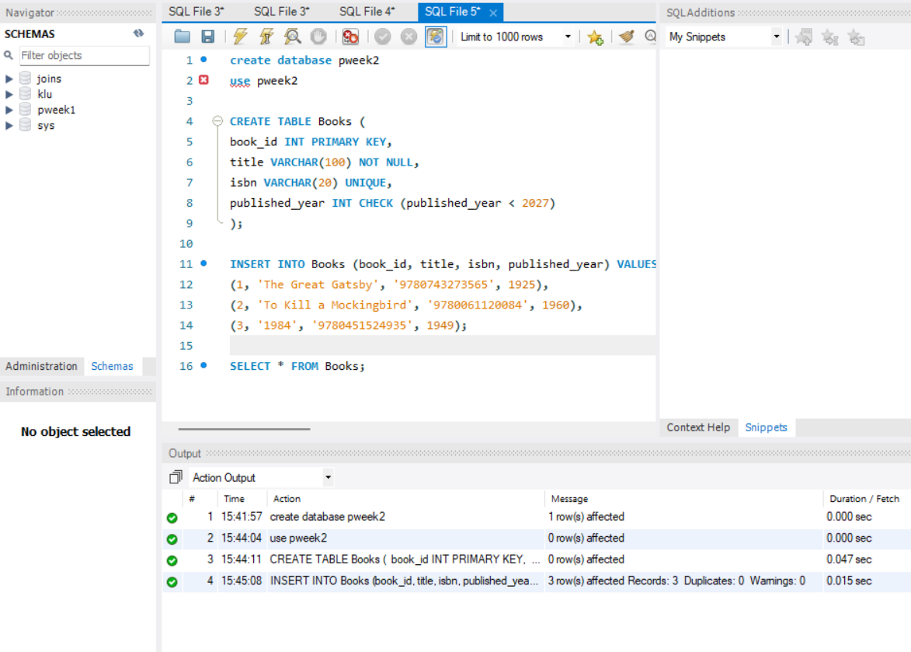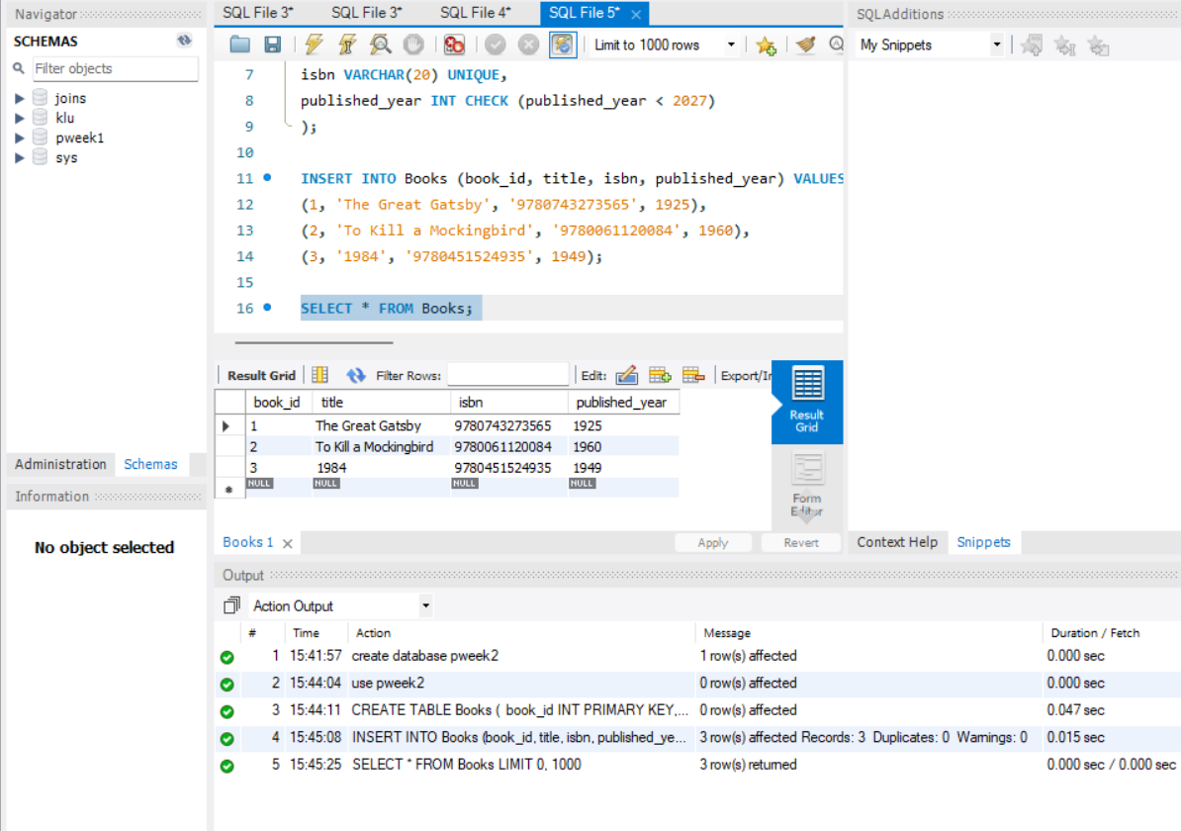

Step 5, 6 & 7 — Members Table: Create, Insert, Display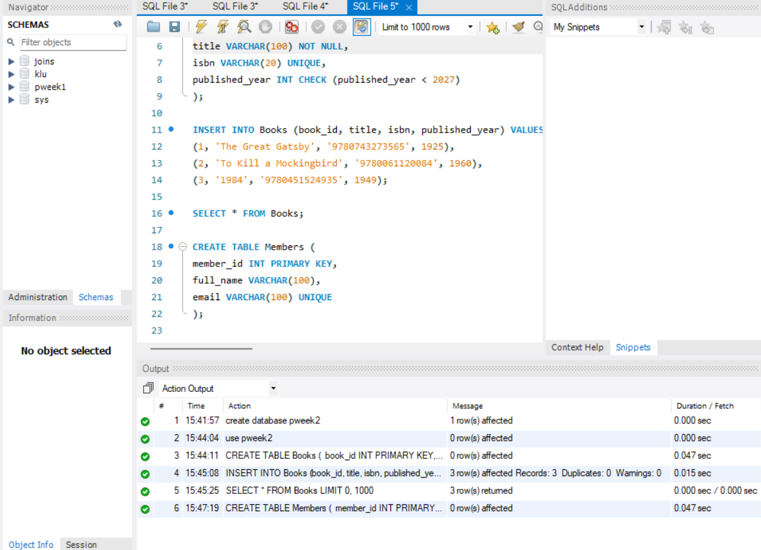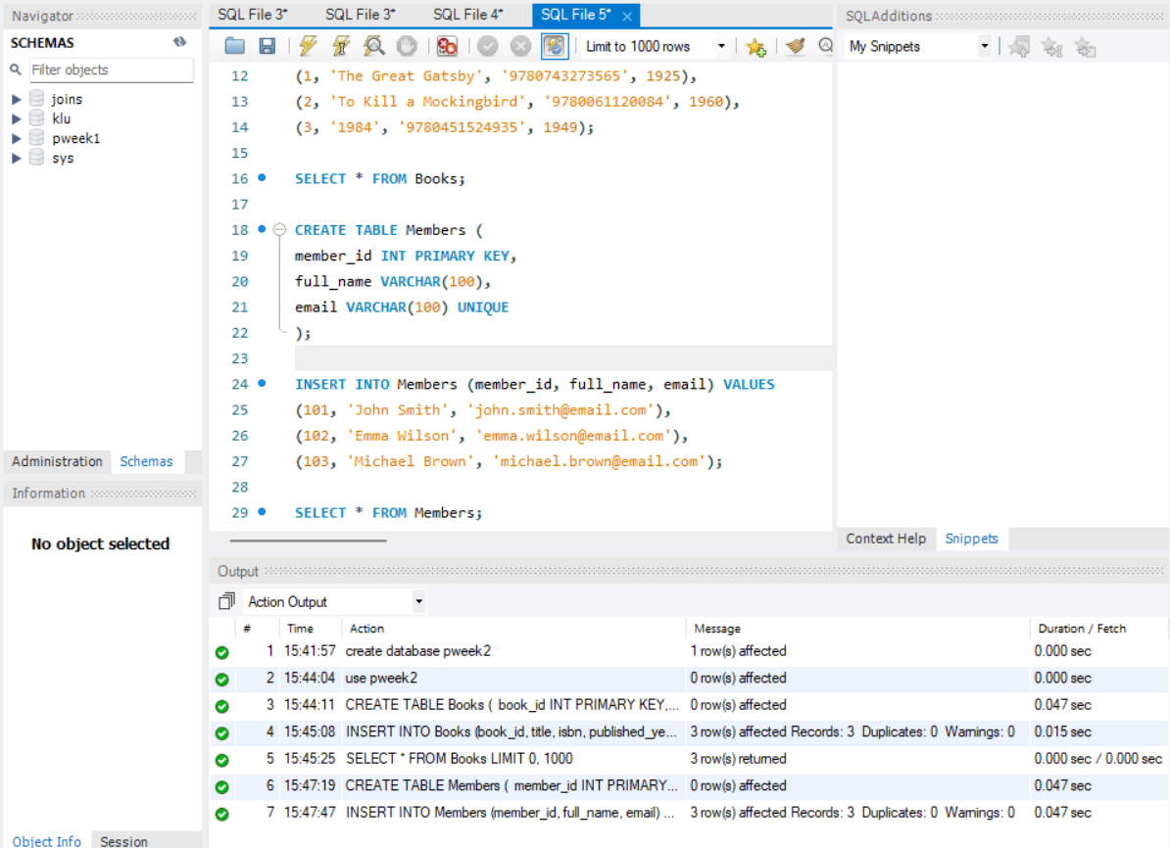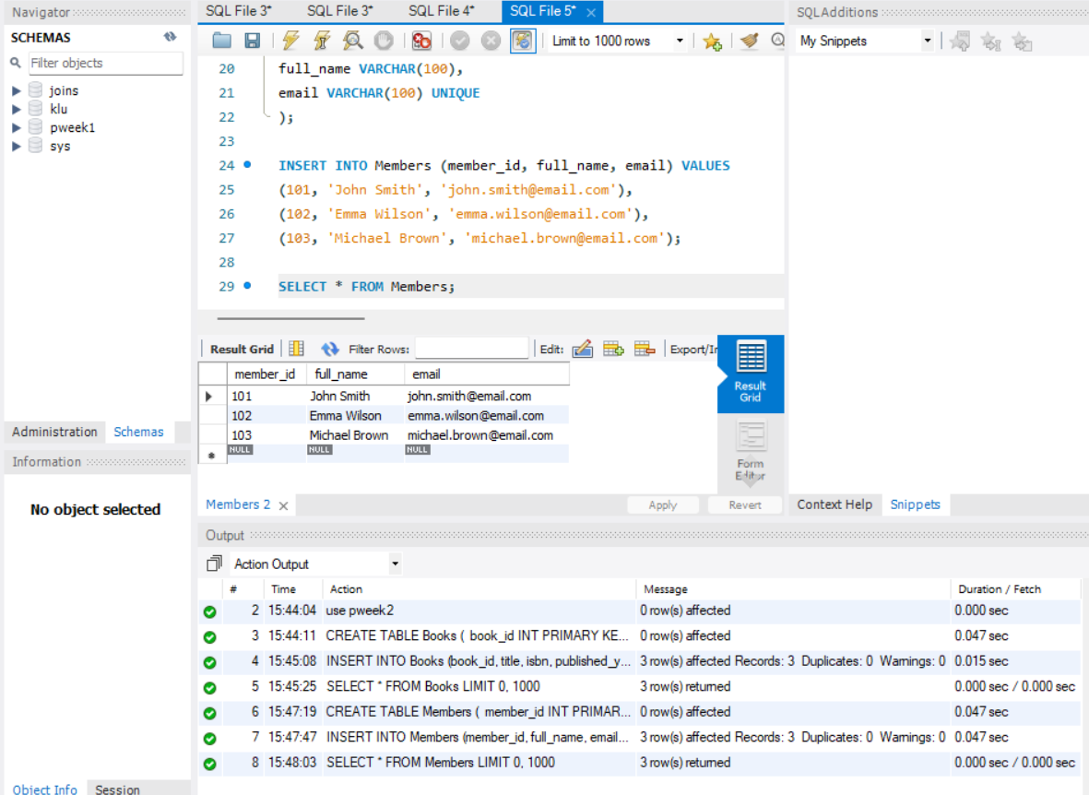

Step 8 — Create Loans Table (FOREIGN KEYS)
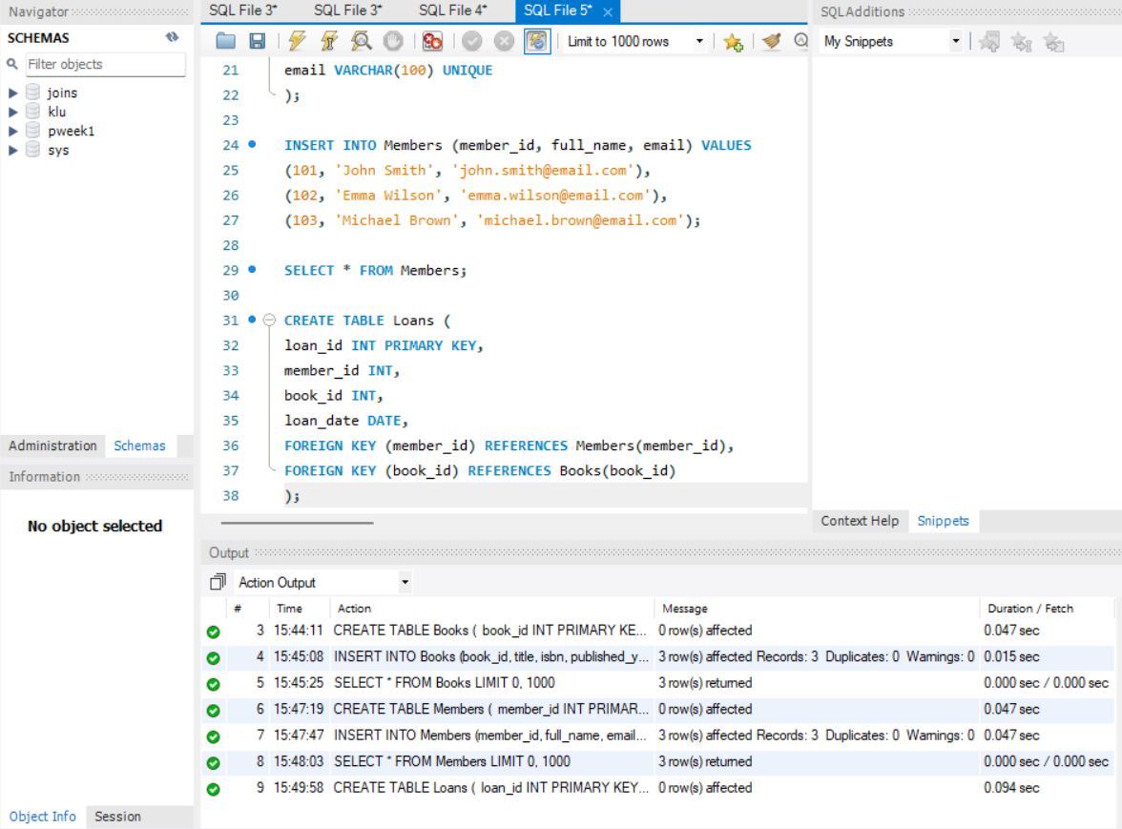

Step 9 & 10 — Insert 10 Loans and Display
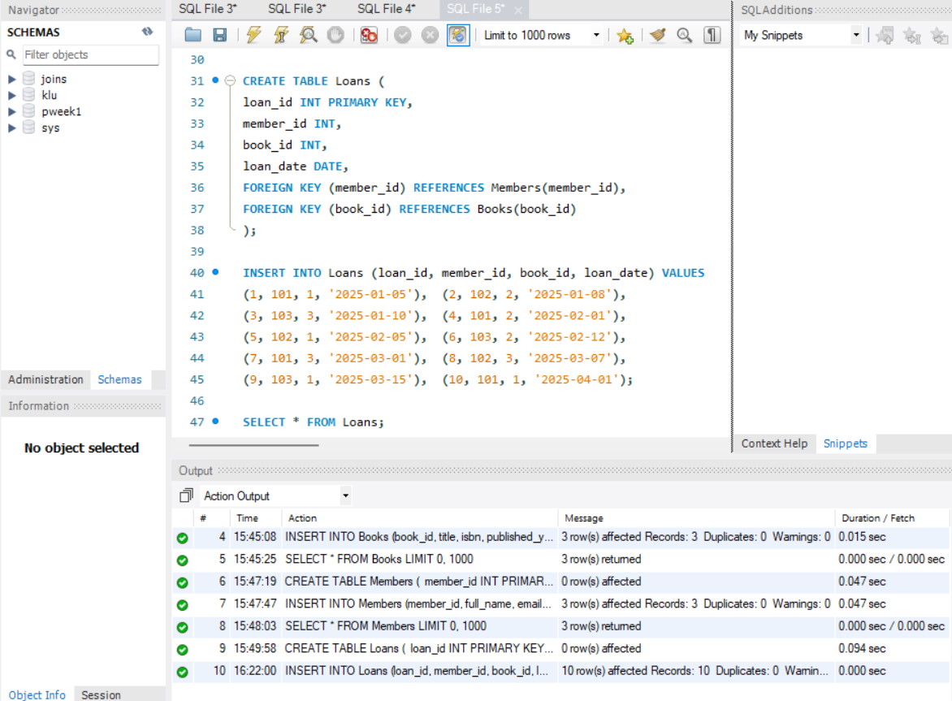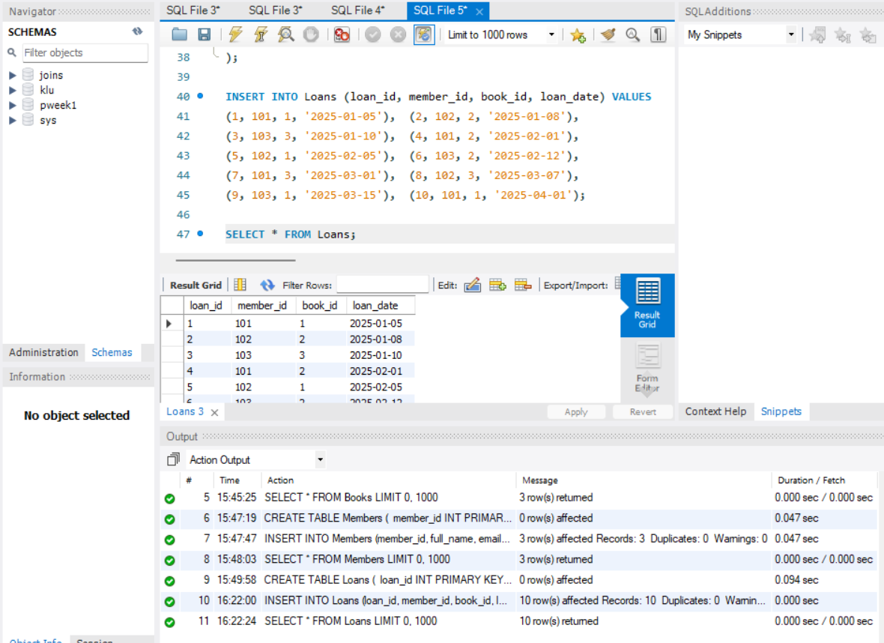

Step 11 — JOIN Query
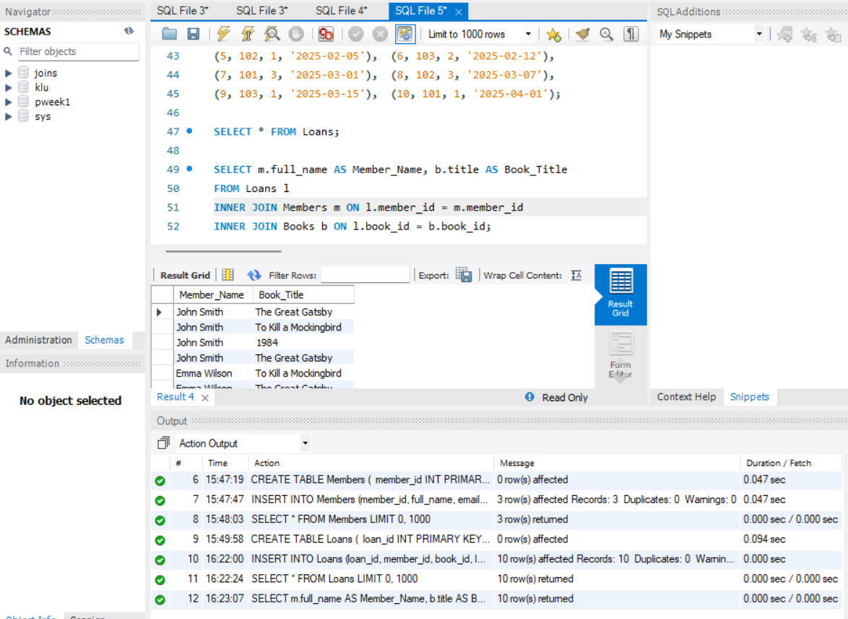
Step 12 — GROUP BY Query
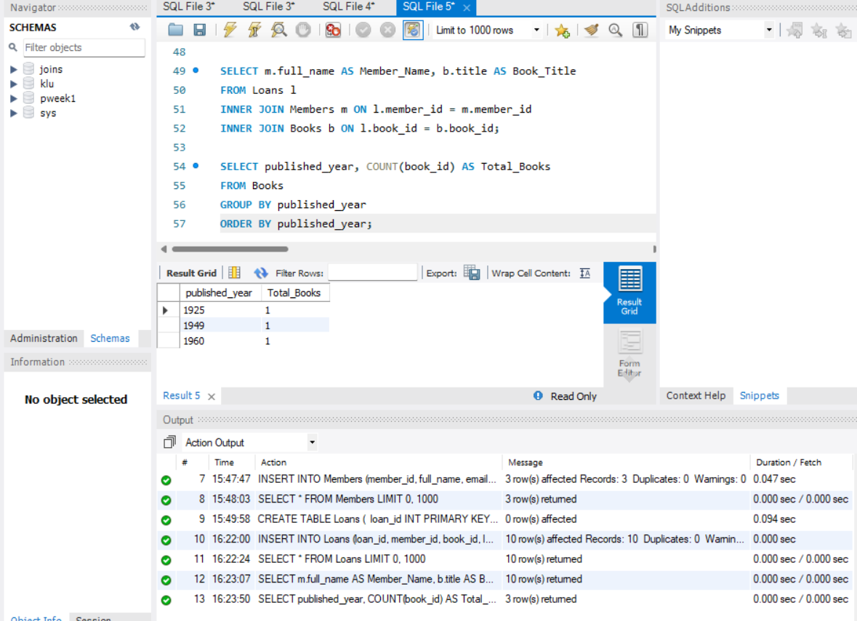

Step 13–16 — Donation via TRANSACTION (Atomicity)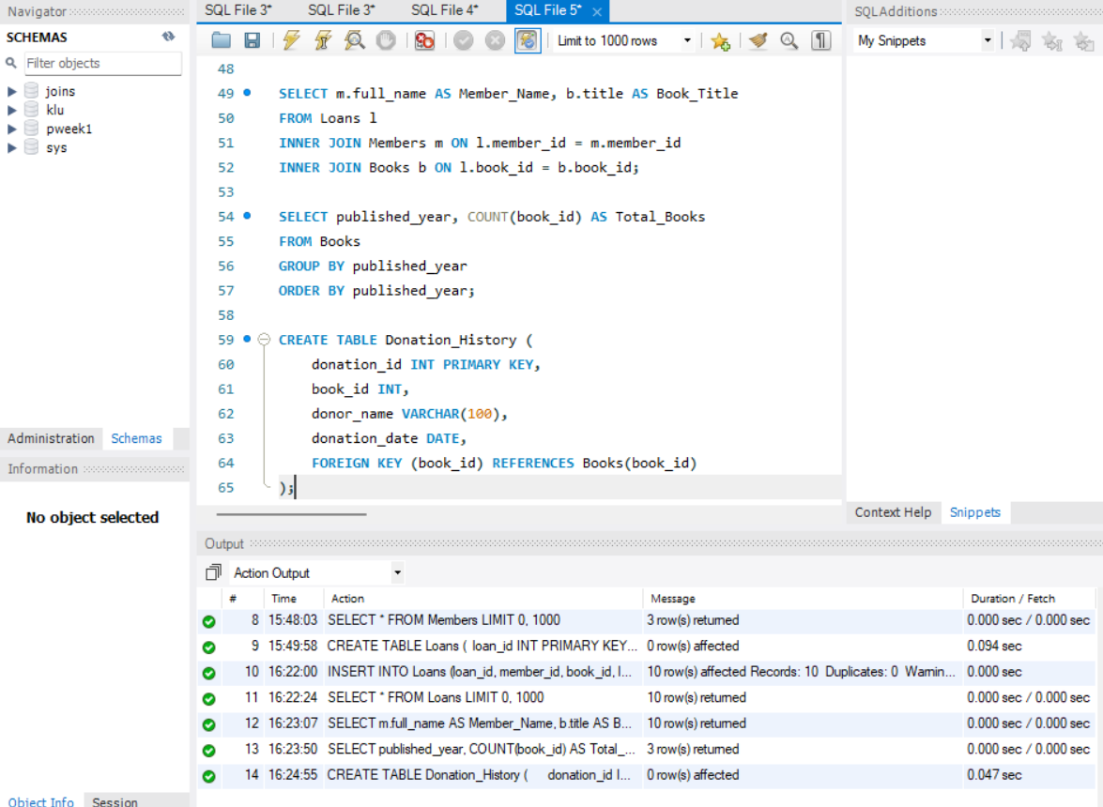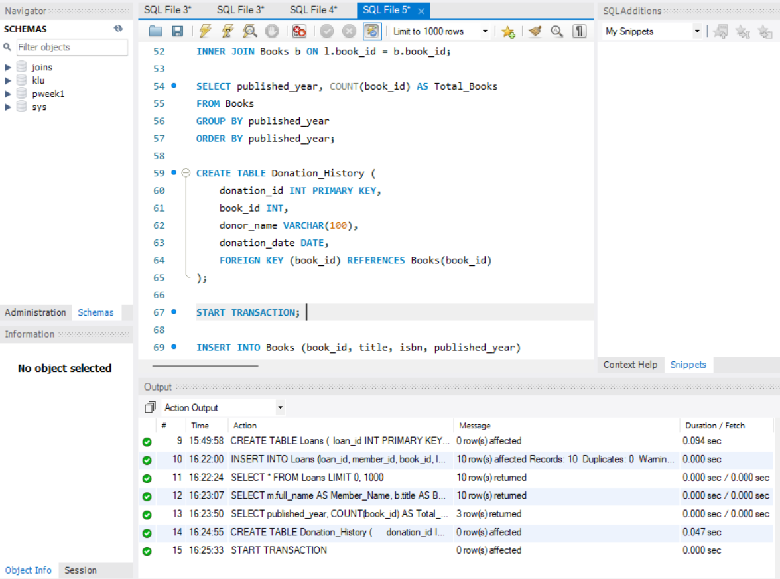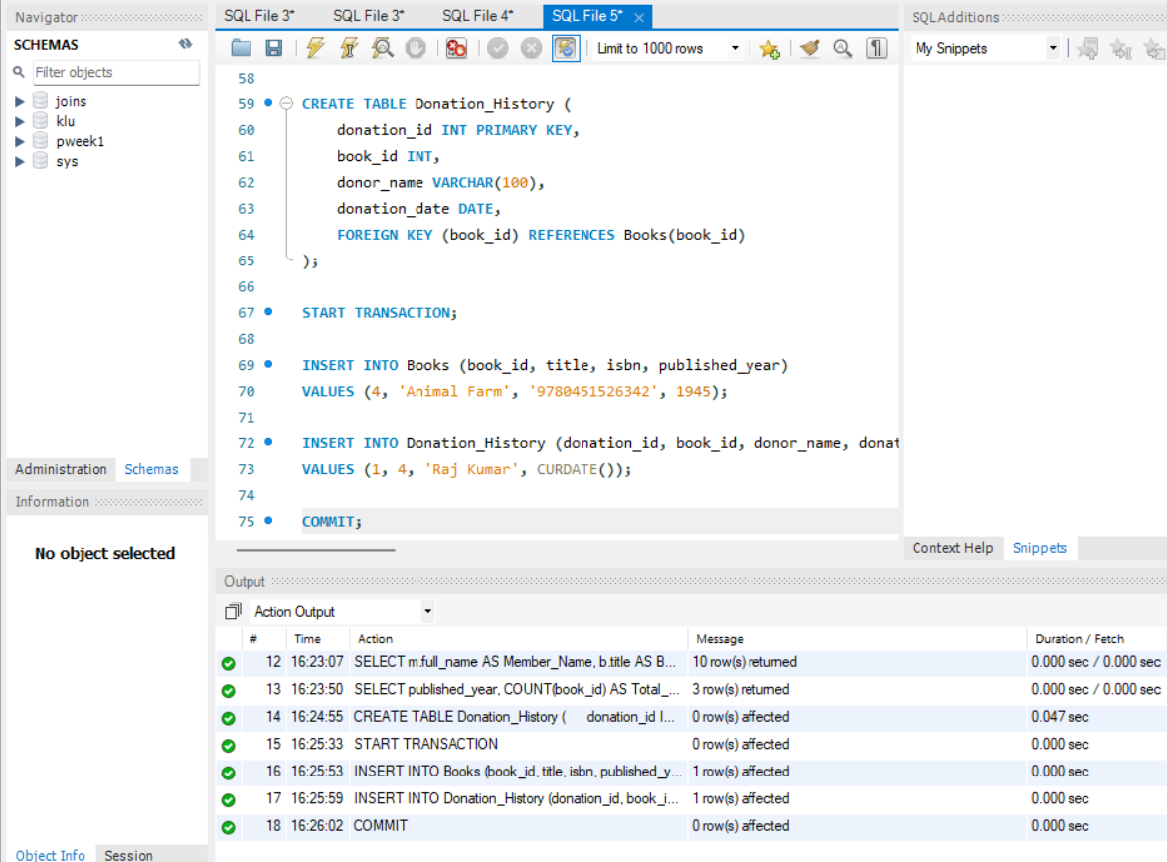

Step 17 & 18 — Index on ISBN + Fast Search
